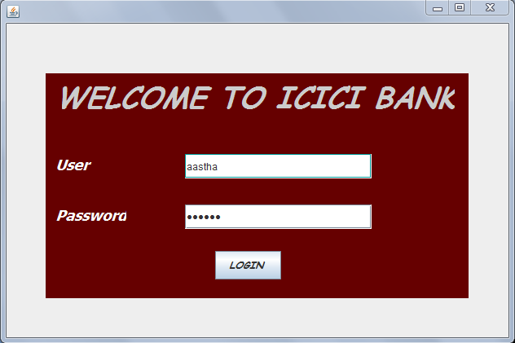

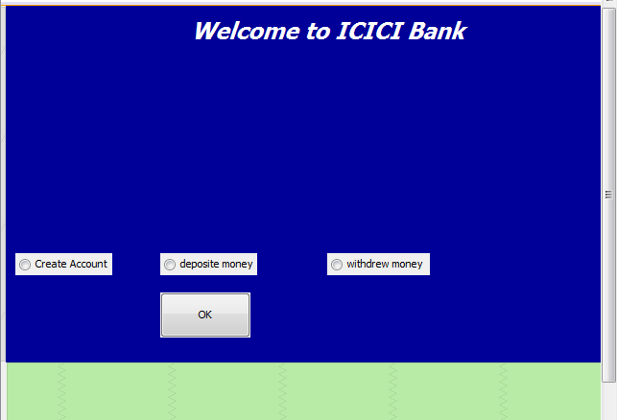

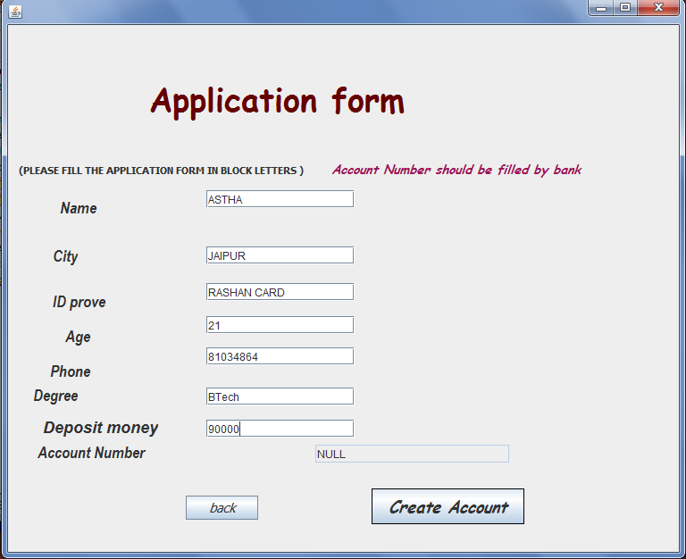

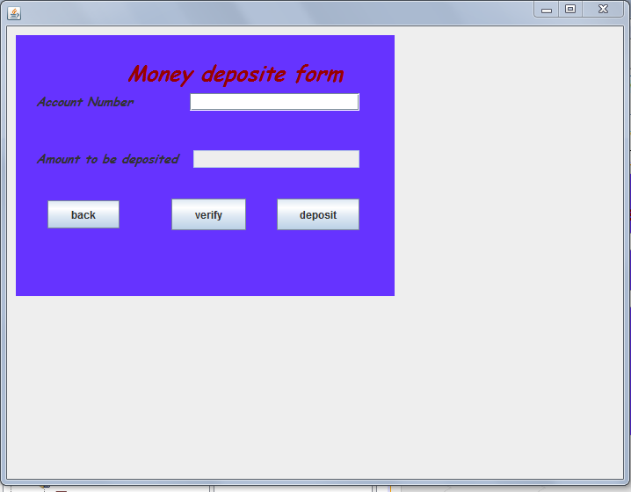

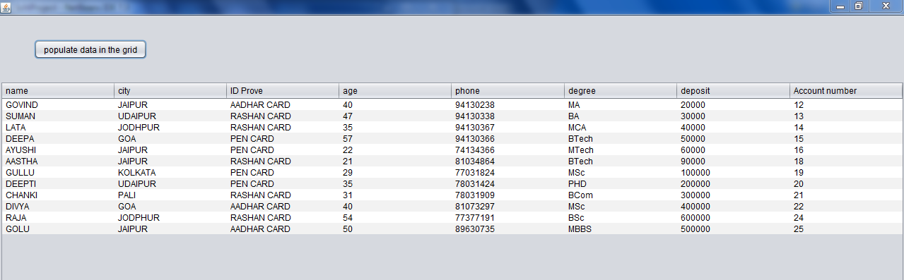

CODING private void jButton1ActionPerformed(java.awt.event.ActionEvent evt) {

String pwd1 = new String(pwd.getPassword());

if (pwd1.equals("aastha")) {

// l5.setVisible(true);

icic obj = new icic();

this.dispose();

obj.setVisible(true);

} else {

// l5.setVisible(true);

l5.setText("Password is invalid ");

}

2) private void jButton1ActionPerformed(java.awt.event.ActionEvent evt) {

if(craccount.isSelected()){

this.isEnabled(false);

create obj = new create();

obj.setVisible(true);}

//if(balance.isSelected()){ this.disable();

//firstpage obj = new firstpage();

//obj.setVisible(true);}

if(depo.isSelected()){ this.isEnabled(false);

deposit obj = new deposit();

obj.setVisible(true);}

if(with.isSelected()){ this.isEnabled(false);

withdraw obj = new withdraw();

obj.setVisible(true);}

3)APPLICATION FORM

import java.sql.\*;

import java.sql.Connection;

import java.sql.DriverManager;

import javax.swing.\*;

try{

Class.forName("java.sql.Driver");

Connection con = DriverManager.getConnection("jdbc:mysql://localhost/3306/schoolproject","root","root");

String query = "insert into account values("

+ "'"+tname.getText()+"','" + tadd.getText()+ "','"

+tid.getText()+"',"

+tage.getText()+",'"

+tph.getText()

+"','"+ thsc.getText()+"',"

+tac.getText()+","+deposit.getText()

+");";

System.out.println(query);

//System.out.println(query);

Statement stmt = con.createStatement();

stmt.executeUpdate(query);

// String query2 = "insert into balance values("+tac.getText()+",0);";

// Statement stmt2 = con.createStatement();

// System.out.println(query2);

// stmt.executeUpdate(query2);

stmt.close();

// stmt2.close();

con.close();

JOptionPane.showMessageDialog(null,"account is created ..!!");

}

catch(Exception e){

JOptionPane.showMessageDialog(null,"Error in connectivity");

}

}

4) MONEY DEPOSIT FORM

try {

Class.forName("java.sql.Driver");

Connection con = DriverManager.getConnection("jdbc:mysql://localhost/3306/schoolproject","root","root");

Statement stmt = con.createStatement();

String crit = taccno.getText();

int y = Integer.parseInt(crit);

String query ="SELECT accn FROM account WHERE accn="+crit+";";

//System.out.println(query);

ResultSet rs = stmt.executeQuery(query);

while (rs.next()){

// model.addRow(new Object[]{

// rs.getInt(1),rs.getString(2),rs.getInt(3)});

String x= rs.getString("accn");

int accno = Integer.parseInt(x);

if(y==accno){

jp.showMessageDialog(null,"Please deposit your money");

tdepo.setEditable(true);

taccno.setEditable(false);

System.out.println("yes");

}

else if(y!=accno){

System.out.println("no");

}

}

rs.close();

stmt.close();

con.close();

}

catch(Exception e ){

JOptionPane.

showMessageDialog(null,"Error in connectivity");

}

// TODO add your handling code here:

}

private void jButton1ActionPerformed(java.awt.event.ActionEvent evt) {

int dep = Integer.parseInt(tdepo.getText());

try{

Class.forName("java.sql.Driver");

Connection con = DriverManager.getConnection("jdbc:mysql://localhost/menagerie","root","abc");

String query = "insert into deposit values("+taccno.getText()+","+dep+");";

//String query2 = "Update balance set balance = balance + "+dep+" where accn = " + taccno.getText()+" ; ";

System.out.println(query);

//System.out.println(query2);

Statement stmt1 = con.createStatement();

stmt1.executeUpdate(query);

Statement stmt2 = con.createStatement();

// stmt1.executeUpdate(query2);

JOptionPane.showMessageDialog(null,"Money deposited.");

stmt1.close();

stmt2.close();

con.close();

} catch(Exception e){

JOptionPane.showMessageDialog(null,"Error in connectivity");

}

5)TABLE

import java.sql.Connection;

import java.sql.DriverManager;

import java.sql.ResultSet;

import java.sql.Statement;

import javax.swing.table.DefaultTableModel;

try

{

Class.forName("java.sql.DriverManager");

Connection con= DriverManager.getConnection("jdbc:mysql://localhost:3306/schoolproject","root","root");

String sql="select \* from account";

Statement st=con.createStatement();

ResultSet rs=st.executeQuery(sql);

DefaultTableModel model=(DefaultTableModel)jTable1.getModel();

int rows=model.getRowCount();

if(rows>0)

{

for(int i=0;i<rows;i++)

{

model.removeRow(0);

}

}

String name,city,IDprove,age,phone,degree,deposit,accno;

while(rs.next())

{

name=rs.getString("name");

city=rs.getString("city");

IDprove=rs.getString("IDprove");

age=rs.getString("age");

phone=rs.getString("phone");

degree=rs.getString("degree");

deposit=rs.getString("deposit");

accno=rs.getString("accno");

model.addRow(new Object[]{name,city,IDprove,age,phone,degree,deposit,accno});

}

}

catch(Exception e)

{

e.printStackTrace();

}

}

MYSQL WORK



 